- Purpose
  - The purpose of this document is to describe the procedure for assembling the knob on an orbital machine.
- Scope
  - This SOP applies to all equipment assembly team members. The process applies to the following machine ID’s:
E012801EQM0600BA1000 – Basic Sand Dragon, 20”
E012801EQM0607BE1200 – Crewman ORB 20
E012801EQM0607BA1200 – Basic Sand Dragon 20, Canadian
E012801EQM0607BE1200 – Crewman ORB 20, Canadian
E012806EQM0600BA1000 – Basic Sand Dragon, 20”, w/ Weights
E012806EQM0600BE1200 – Crewman ORB 20, w/Weights
E012806EQM0607BA1200 – Basic Sand Dragon 20, w/Weights, Canadian
E012806EQM0600BE1200 – Crewman ORB 20, w/Weights, Canadian
E012811EQM0600BA1000 – Basic Sand Dragon, 28”, w/Weights
E012811EQM0600BE1000 – Crewman 28 ORB, w/Weights
E012811EQM0607BA1200 – Basic Sand Dragon 28, w/Weights, Canadian
E012811EQM0607BE1200 – Crewman ORB 28, w/Weights Canadian

- Responsibilities
  - The operations manager/supervisor is responsible for enforcing this SOP.
- Materials
  - The proper materials needed for this process are listed on the machine work order.
  - Pin assembly fixture
  - Snap ring pliers
- Definitions

- Procedure
  - Take 2 center bolts (89708) and place them in the assembly fixture as shown. The pins in the nest go into the top holes on the center bolts.

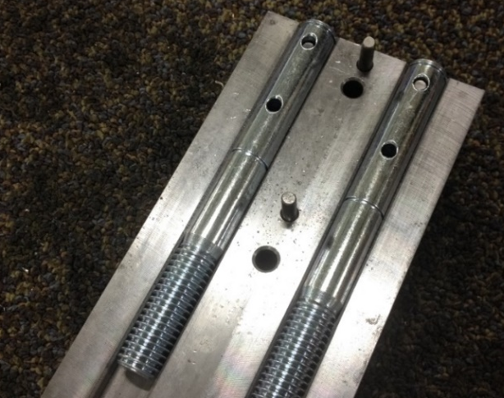
  - Place the top nest in place.

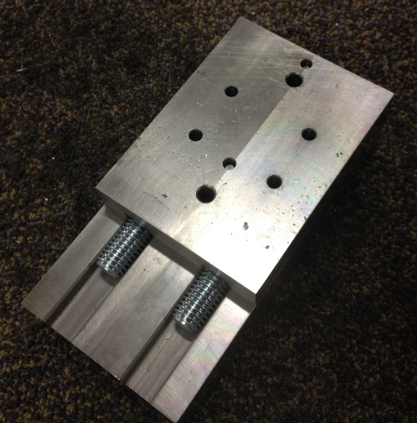

  - Put a spring pin (89709) into each of the two holes shown.

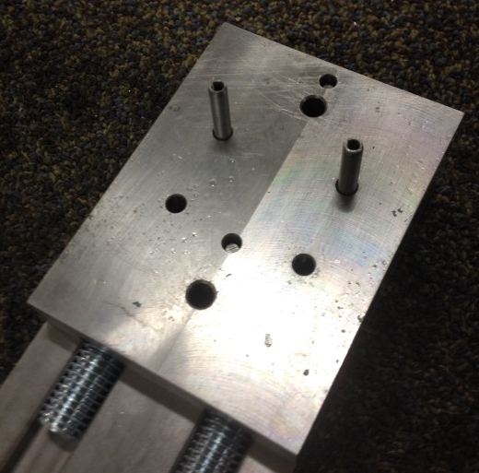

  - Put the top plate into place. The dowel pins go into the holes in the nest.

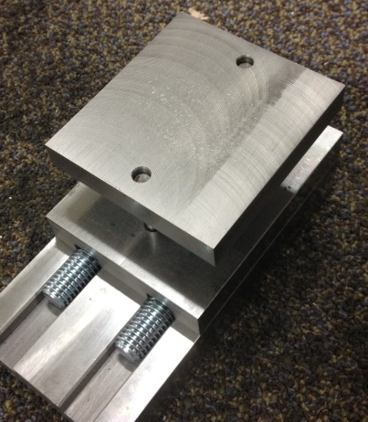
  - Put the assembly into a press and press the top plate until it makes contact with the nest. This will fully insert the spring pins.

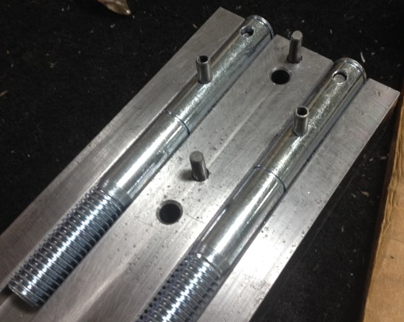

  - Move each center bolt down in the nest until the spring pin that was just pushed in locates itself in another hole.

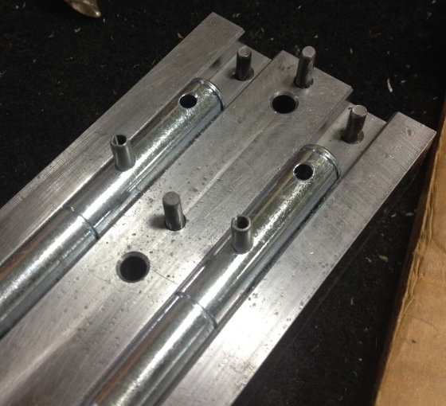

  - Repeat the process. Press 2 more spring pins (89709) into the holes shown.

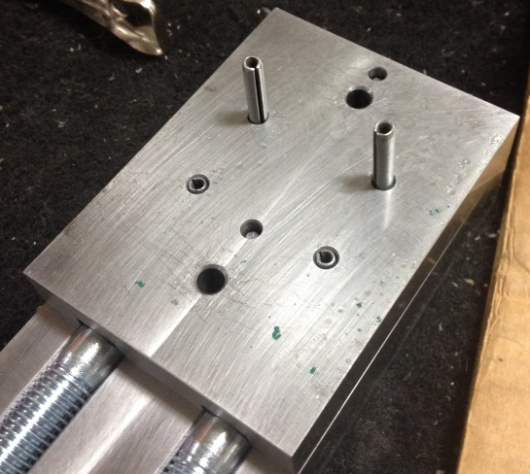
  - Remove the center bolts from the nest.

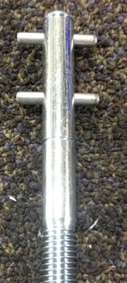

  - Install a snap ring (89711) into the bottom groove on the center bolt as shown.

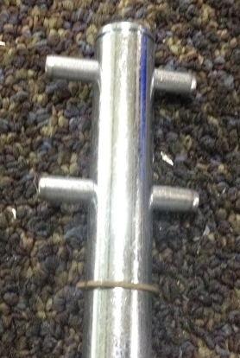

  - Slide a knob (89710) over the top end of the center bolt. Install another snap ring (89711) into the top groove on the center bolt.

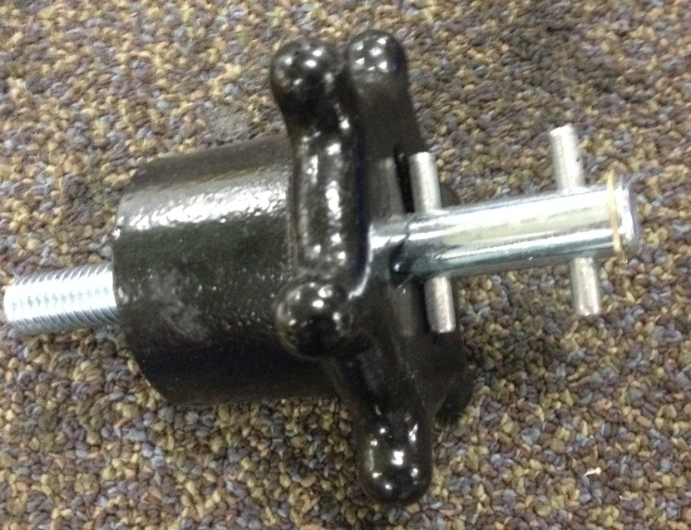
- References (optional section as needed)

- Training Guide

Functional Training Groups Requiring Training
Equipment Assembly Group

- SOP Change Control

Date of Change | Reason for Change
Rev 01 - 4/28/2015 | This is the first version of the S.O.P. hence there are no revisions to this document.
Rev 02 - 1/16/2018 | Added the Responsibilities Section
Rev 03 - 10/15/2024 | Updated Machine ID’s
Rev 04 - 3/6/2025 | Removed work center note

Approvals

Submitter/Author Approval:__________________________________ Date:______________________

Management Approval:______________________________________ Date:______________________

QAU Approval:_____________________________________________ Date:______________________

